Qualcomm Developer Project
Assets / People tracking system
Attribution:
Email address | fuly0408@thundersoft.com  liuwf0406@thundersoft.com  xiaofei.hu@thundercomm.com
Project Title* | Assets / People tracking system
Description*  High level description of the project (75 words or less) | Use TURBOX T95development components to implement asset / person tracking  使用TURBOX T95开发组件实现对资产/人员跟踪的功能
Images  Upload up to 5 images of your project  Please submit/send the original JPEG/PNG files for all images included in the document | TURBOX T95 (MDM 9205)
  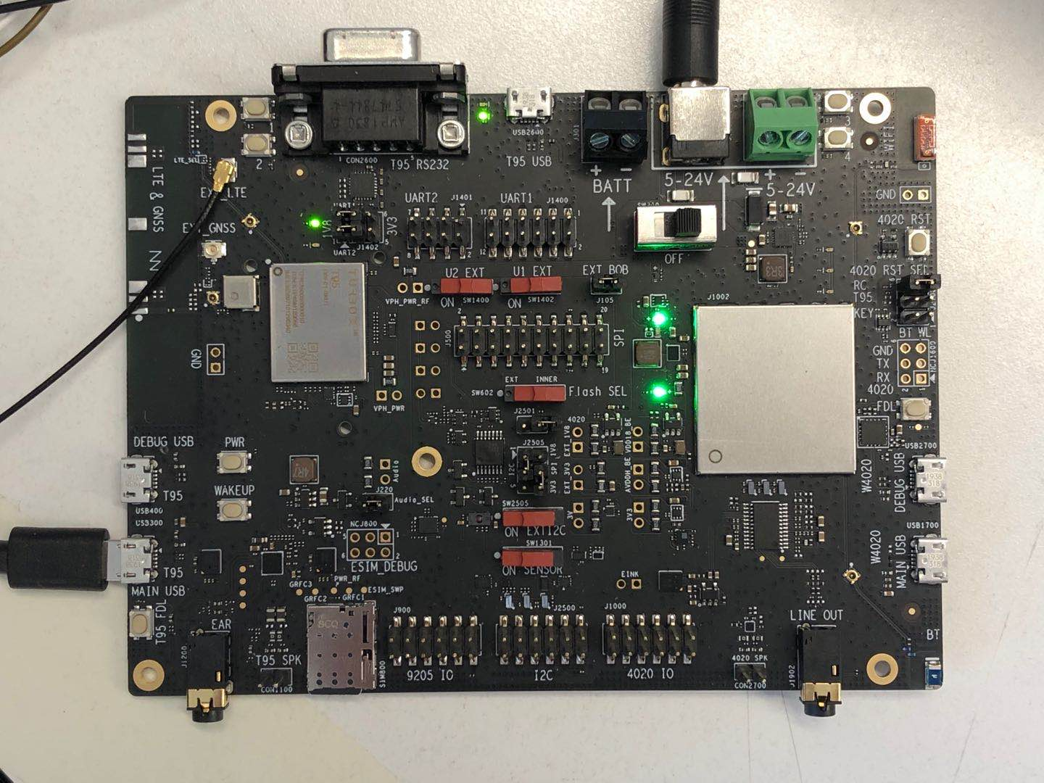
Objective  - What inspired you to create this project?  - What is your desired outcome? | Mainly use buttons or other interrupts to trigger messages, use GPS and wifi modules to locate the device, and then use the network communication module in the module to implement Assets / People tracking system.（主要是通过按钮或其他中断触发消息，使用GPS和wifi模块对设备进行定位，再通过模组中的网络通信模块，实资产/人员的跟踪）
Operation System*  (Android, Linux, Windows 10 IoT Core) |  Android  Linux  RTOS |  | Windows 10 IoT Core  Ubuntu Core
Cloud Services/Platform  AT&T M2X, AWS IoT, IBM Bluemix, IBM Watson IoT, Such as Microsoft Azure IoT) | Amazon AWS IoT  AT&T M2x  IBM Bluemix |  | IBM Watson IoT  Gizwits Cloud  Google Cloud Platform
Skill Level Required  (Beginner, Intermediate, Advanced) | Advanced  Beginner |  | Intermediate
Areas of Focus  (e.g., IoT, smart cities, smart home, robotics, hardware, gaming, healthcare, automotive, digital signage, etc.) | 3D Printing & Modeling  Alexa Voice Service  Bluetooth  Computer Vision  Digital Signage  Education  Embedded  Gaming |  | Healthcare  Robotics  Sensors  Smart Cities  Toys
Materials Required / Parts List / Tools | Part Name | Link
Materials Required / Parts List / Tools | TURBOX T95 | https://www.thundercomm.com/app_en/store/detail/1577783630023328
Source Code / Source Examples / Application Executable  Link to open source / shareable code repository | Description | Link
 | Source Code | https://github.com/ThunderSoft-XA/
Additional Resources  List related links or resources such as websites, videos, presentations, or other materials | Resource Title | Link or File Name (and provide file)
 | TURBOX T95 | https://www.thundercomm.com/app_en/store/detail/1577783630023328
Build / Assembly Instructions | Parts used  Below are the items used in this project.（以下是本项目中使用到的部分。）  parts.png  - Win7 PC.（windows7台式机）  - Turbox T95 .（Turbox T95 开发板）  - USB data cable.（usb数据连接线）  Deploying the project  - According to the demand of demo, purchase turbox T95 development board.（根据demo的需求，购买TURBOX T95开发板。）  - Test if the optional device is available.（检测器件是否可用。）  - Build and debug hardware circuits.（搭建和调试硬件电路。）  - Create a demo-Assets-People-tracking-system project locally.（创建本地项目“demo-Assets-People-tracking-system”。）  - Transplant relevant source code.（移植相关源代码。）  - Development of information interruption module.（开发信息中断模块）  - Development of GPS positioning module.（开发gps定位模块。）  - Development of network communication modules.（开发网络通信模块）  - Joint debugging.（联合调试。）  - Code uploaded to github.（上传代码到github。）  How does it work?  Below are some usage instructions to test the project.（下面是测试项目的使用说明。）  Now let's introduce the demo-Assets-People-tracking-system workflow.（现在我们介绍“demo-Assets-People-tracking-system”的工作流程。）  dam_app_routine---->upload_dev_info---->app_coap_send_tracker_alarm_message_func---->app_coap_send_tracker_alarm_message  Sample_Applications\io9205_track\src\demo\io9205_net.c  t95_dss_cb:  static void  t95_dss_cb( qapi_DSS_Hndl_t hndl, /* Handle for which this event is associated */  void *user_data, /* Application-provided user data */  qapi_DSS_Net_Evt_t evt, /* Event identifier */  qapi_DSS_Evt_Payload_t *payload_ptr) /* Associated event information */  {  // ...  if (evt == QAPI_DSS_EVT_NET_IS_CONN_E)  {  // ...  ret = t95_coap_init();  if (ret != 0)  {  LOG_ERROR("*****t95_coap_init failed!***** ret = %d", ret);  }  }  // ...  }  The function is used to initialize the COAP module after the DSS is settled in the network.（这个函数的作用是dss驻网完毕后初始化COAP模块）  Sample_Applications\io9205_track\src\demo\track_demo_module.c  dam_app_routine  void dam_app_routine(void)  {  // ...  while (1)  {  // ...  if (ret == 0)  {  LOG_INFO("upload_dev_info succeed\n");  qapi_Timer_Sleep(3, QAPI_TIMER_UNIT_SEC, true);  }  else  {  LOG_INFO("upload_dev_info failed\n");  qapi_Timer_Sleep(3, QAPI_TIMER_UNIT_SEC, true);  }  LOG_INFO("upload_dev_info end\n");  // ...  }  // ...  }  This function is used to execute the escalation logic after the button is triggered.（此函数的作用是按钮触发后执行上报逻辑）  Sample_Applications\io9205_track\src\demo\io9205_coap_control.c  app_coap_send_tracker_alarm_message_func  qapi_Status_t app_coap_send_tracker_alarm_message_func(void)  {  LOG_INFO("app_coap_send_tracker_alarm_message_func call!\n");  if (app_coap_init_message() != QAPI_OK)  {  LOG_INFO("app_coap_send_tracker_alarm_message_func : set init failed!\n");  return QAPI_ERROR;  }  if (app_coap_set_header() != QAPI_OK)  {  LOG_INFO("app_coap_send_tracker_alarm_message_func : set header failed!\n");  return QAPI_ERROR;  }  if (app_coap_send_tracker_alarm_message() != QAPI_OK)  {  LOG_INFO("app_coap_send_tracker_alarm_message_func : send message failed!\n");  return QAPI_ERROR;  }  LOG_INFO("app_coap_send_tracker_alarm_message_func : send message over!\n");  return QAPI_OK;  }  The function of this function is the network communication module, which sets and initializes the context message.（这个函数的功能是网络通信模块，设置和初始化上下文消息）  Sample_Applications\io9205_track\src\demo\io9205_coap_control.c  app_coap_send_tracker_alarm_message  QCLI_Command_Status_t app_coap_send_tracker_alarm_message()  {  size_t payload_len = ALARM_MSG_LEN;  marin_msg = 0;  display_time_get(&now_time, TEST_TIME_ZONE);  coap_message_param.lastmid = (uint16_t *)0;  coap_message_param.token = "xxxxxx"; // xxxxxx  coap_message_param.token_len = 0;  if (up_info)  {  if (qapi_Coap_Set_Payload(app_coap_hndle, app_coap_message,  payload, payload_len) != QAPI_OK)  {  COAP_PRINTF("app_coap_send_test_message error\n");  return QAPI_ERROR;  }  }  if (qapi_Coap_Send_Message(app_coap_hndle, app_coap_message,  &coap_message_param) != QAPI_OK)  {  COAP_PRINTF("qapi_Coap_Send_Message returned error\n");  return QAPI_ERROR;  }  return QAPI_OK;  }  The function of this function is to implement the sending steps of network communication.（这个函数的功能是实现网络通信的发送步骤）
Usage Instructions | - Downloading code from Github and TS.（从Githut和创达处获取源码。）  - Merge code, append the code and add the io9205_coap_control.h / .c to the source code（在io9205_track项目下合并代码,修改新增代码以及添加io9205_coap_control.h / .c 文件到源码中）  - Compile the code and flash the image to TURBOX T95development board.（编译代码并烧录镜像到TURBOX T95开发板。）  - Click the button to report the current location information（单击按钮，上报当前位置信息。）  - Log in to the management server to view location information（登录管理服务器，查看位置信息。ID:tracker-demo PWD:test123456）
Contributor(s) Info  Feel free to include headshots! | Name | Title  Company
Contributor(s) Info  Feel free to include headshots! | fuly0408@thundersoft.com | Thundersoft
Contributor(s) Info  Feel free to include headshots! | liuwf0406@thundersoft.com | Thundersoft
Contributor(s) Info  Feel free to include headshots! | xiaofei.hu@thundercomm.com | Thundersoft

By submitting your content (“Submission”), you are granting Qualcomm a royalty-free, perpetual, non-exclusive, unrestricted, worldwide license to: (a) post, use, copy, sublicense, adapt, transmit, publicly perform or display any such Submission, (b) use, reproduce, modify, adapt, publish, translate, create derivative works from, distribute, perform, play, host, communicate, make available and publish your Submission without restriction and (c) sublicense to third parties the unrestricted right to exercise any of the foregoing rights granted with respect to the Submission. The foregoing grants shall include the right to exploit any ideas, concepts, intellectual property, or proprietary rights in such Submission, including but not limited to rights under copyright, trademark, servicemark or patent laws under any relevant jurisdiction without Qualcomm owing any monies to you whatsoever. You represent and warrant that you own all right, title and interest in and to the Submission, or you have been granted sufficient rights in and to the Submission allowing the foregoing use of such Submission.

